Contact Information Management

1. **Data Analysis:** -
2. Agenda for the application: -

The main motto of the application is to gather different information from the users like name, mobile number, gender etc for the application form in order to register for the freedom company.

1. Data to be captured :-

Name (As per birth-certificate)

Mobile number

E-Mail Id

Date of Birth

Gender

Nationality

Marital Status

Age

1. **Functional requirements Specification**: -
2. Wire frames :-

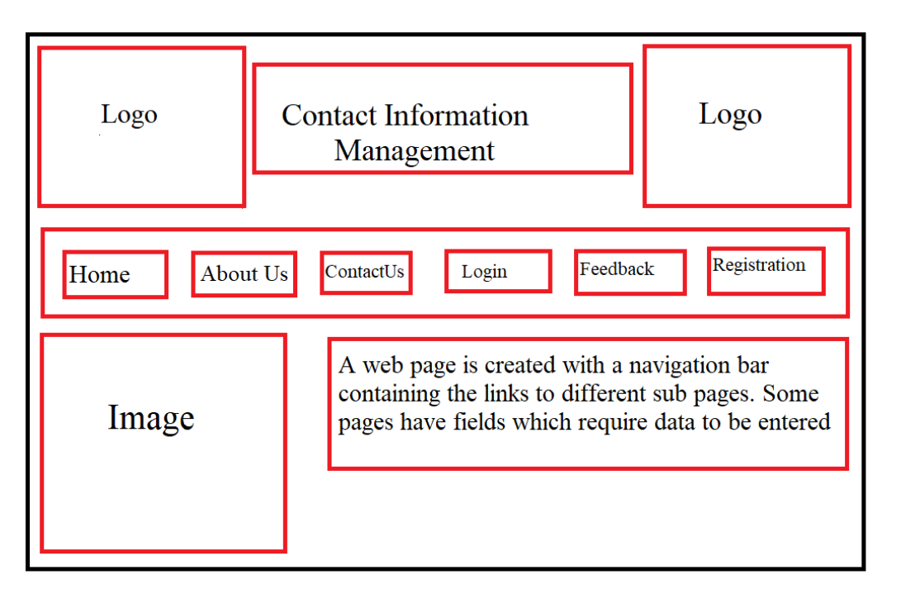

1. Descriptiob. Description on their functionality :-

Company logo is published at top right and left of the home page along with the project title at the center of the page.

Right below is the navigation bar which contains six fields “Home, About Us, Contact Us, Login, Feedback, Registration.On clicking, each field is redirected to another page depending on the field the user selects.

1. Home - It is the homepage of a website.
2. About us - It contains information about the company

.

1. Contact us - It contains the details for support from the company.
2. Login - It asks for username and password in order to login.
3. Feedback - It asks you to fill a form inorder to improve their support.
4. Registration - If you are a new user you need to fill in all the details in order to create a new account in the website.